1. **Agenda**:
   1. How our password is validated by Spring Security by default.
2. 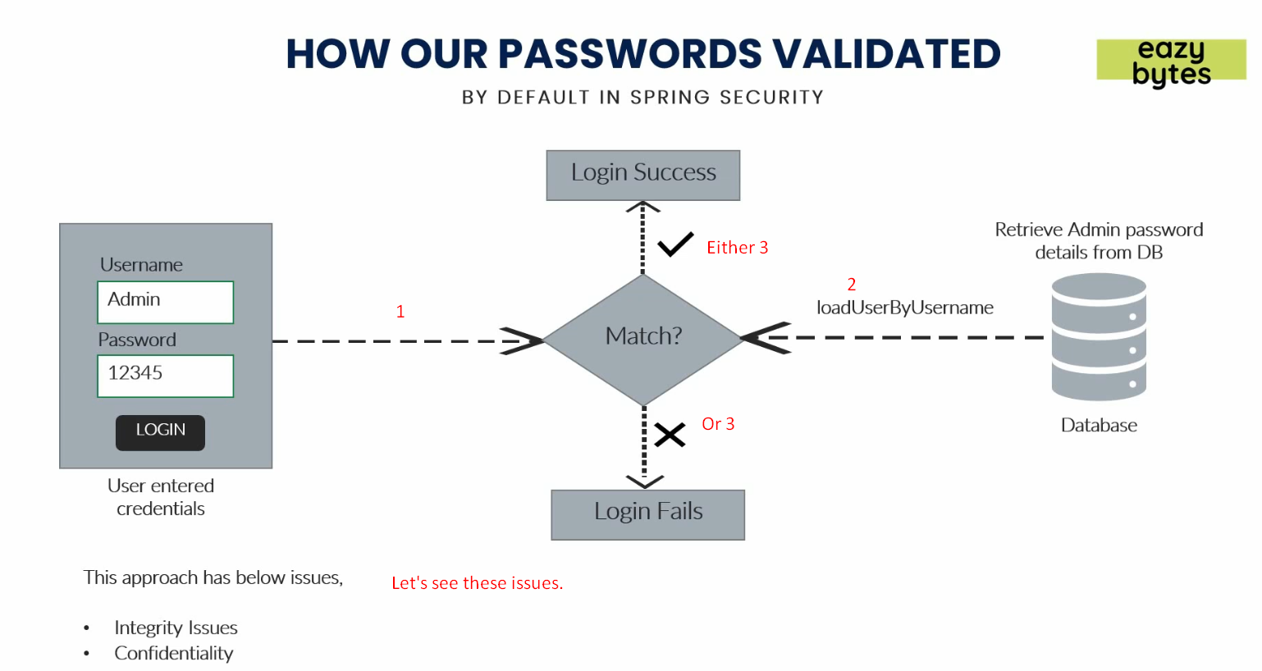  
   Issues with default password validation:
   1. Password is being stored with encoding, encryption or hashing.   
      So anyone such as DBA having authority to login the DB can access the password as it is plain in English.
   2. We’re sending plain password over network.   
      So, any hacker can access it.